**1. High level description:**

**1.1. Technologies Used:**

Development language: Java, c++

Java JDK

Computing device

The objective of this is to make a game that is able to grow and more especially dominate other creations of the game so the games platform will be done with Java but will have C++ as an underlying backbone. Since C++ is faster than Java it is bound to always yield faster results in which decisions have to be made by the game agent.

Java IDK will be used to simulate the graphic features of java in the instance of running the game to visually see the graphics.

**1.2. Deployment diagram:**

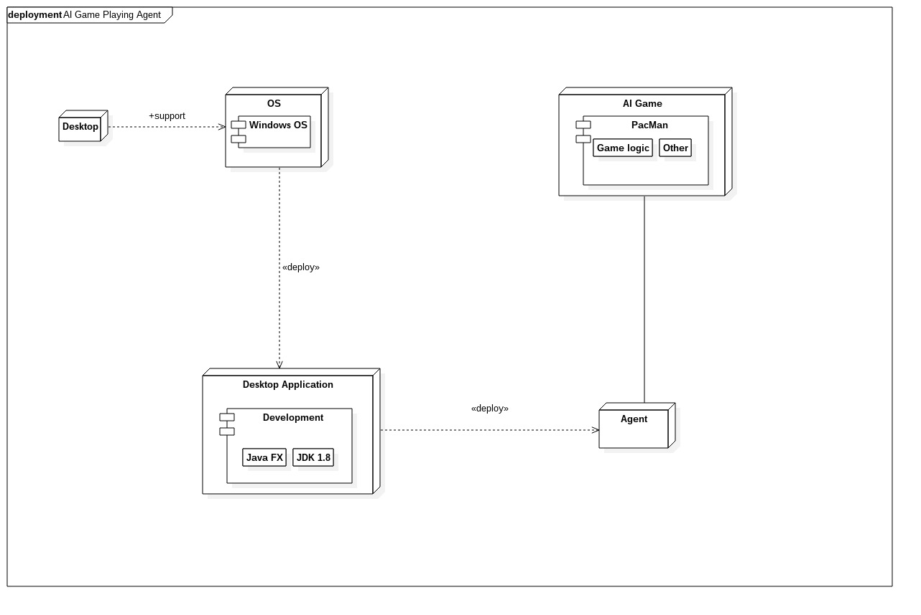

# **2. Deployment methodology:**

After each demonstration the team will have to meet up with the clients. When the demonstration dates are too far apart then a bi-monthly meeting will have to take place with the client. This will give the client an opportunity to share any feedback concerning the project. If the client has any changes that need to be made, he/she will have to make them during said meetings. AGILE principles will be used throughout the software life cycle development process. This will help in developing innovative ideas and increase in efficiency of the implementation stage.

# **3. Team details:**

#### **Melvin Zitha:**

* Programming languages: C++, Java, JavaScript
* Web design
* Concurrent programming
* Quality Control Analysis
* Mathematical Analysis
* Good at solving problems
* MongoDb, Neo4j

My parallel programming skills will help ensure that the game runs well on a multi-threaded environment, and my mathematics skill will help with analysing the efficiency of the algorithms we'll use.

**Nathan Ngobale:**

* Programming languages: C++, Java, Javascript, PHP, Python
* Concurrent programming
* Net centric Computer Systems
* Computer Organisation and Architecture
* Data structures and algorithms
* SQL Database
* Good at mathematical based code

Currently a student in computer science studying AI in the form of cos314 which will come into play here when neural networks, decision trees, training of the agent is to be conducted.

**Nkosenhle Ncube:**

* C and C++ programming
* Java programming
* Assembly programming
* Web Design
* Database design (in SQL and MongoDB)
* Critical thinking
* Time management
* Constructing suitable algorithms for various problem

**Kamogelo Tsipa:**

* Programming - C/C++, Java, Javascript, PHP
* Web Design
* Mathematical modelling
* Reading Comprehension
* Complex Problem Solving
* Active Listening
* Judgment and Decision Making Critical Thinking

I will use my strong mathematical background to develop decision trees and my complex problem solving skills to cover test cases and develop an efficient algorithm needed by the AI agent.

**Nkosinathi Mothoa:**

* Database Design and Implementation
* Concurrent Programming
* OO Programming
* Software Design Patterns
* Data Structures and Algorithms knowledge
* Programming Languages – C++/C, Java (FX, Swing, Android Development)